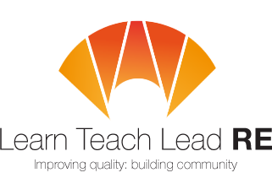

AN INVITATION
To the Bath area RE Hub Meeting
twilight network group
Thursday 6th June 2019 at 4:00-5.30pm
Farrington Gurney Primary School (Church Ln, Farrington Gurney, BS39 6TY)
Agenda:
- Meet and greet with refreshments

Cross phase:
- Guest speaker Iris Segall from the Bristol and West Progressive Jewish Congregation
- Lesson ideas from the AMV syllabus
- Take away resources

Primary & Secondary:
- We will split into primary and secondary and look at applying Judaism subject knowledge to our phases.
Please bring along your favourite resource for teaching Judaism to share and any questions you have about the religion
Free and open to all teachers and HLTAs teaching RE at Primary and Secondary. Everyone is very welcome!
More details: Secondary lead - m.patterson@hayesfield.com
Primary lead – pmarvin@farringtongurneyschool.co.uk
Hubs are affiliated to the National Association of Teachers of RE ​www.natre.org.uk/
For further details of our programme and its partners, please visit our website ​www.ltlre.org
LTLRE hubs are funded through an award from The Jerusalem Trust and St Matthias Trust

